- CREATE TABLE
CREATE TABLE PHONGBAN (
MaPhong INT PRIMARY KEY,
TenPhong VARCHAR(50),
TruongPhong INT,
NgayNhanChuc DATE
);

CREATE TABLE NHANVIEN (
MaNV INT PRIMARY KEY,
HoNV VARCHAR(50),
TenNV VARCHAR(50),
NgaySinh DATE,
DiaChi VARCHAR(50),
Phai VARCHAR(50),
Luong INT,
MaNQL INT,
Phong INT,
FOREIGN KEY (Phong) REFERENCES PHONGBAN(MaPhong)
);

CREATE TABLE DIADIEMPHONG (
MaPhong INT,
DiaChi VARCHAR(50),
PRIMARY KEY (MaPhong, DiaChi),
FOREIGN KEY (MaPhong) REFERENCES PHONGBAN(MaPhong)
);

CREATE TABLE DEAN (
MaDA INT PRIMARY KEY,
TenDA VARCHAR(50),
DdiemDA VARCHAR(50),
Phong INT,
FOREIGN KEY (Phong) REFERENCES PHONGBAN(MaPhong)
);

CREATE TABLE PHANCONG (
MaNV INT,
MaDA INT,
ThoiGian INT,
PRIMARY KEY (MaNV, MaDA),
FOREIGN KEY (MaNV) REFERENCES NHANVIEN(MaNV),
FOREIGN KEY (MaDA) REFERENCES DEAN(MaDA)
);

CREATE TABLE THANNHAN (
MaTN INT PRIMARY KEY,
HoTN VARCHAR(50),
TenTN VARCHAR(50),
Phai VARCHAR(50),
NgaySinh DATE
);

CREATE TABLE NVIEN_TNHAN (
MaNV INT,
MaTN INT,
QuanHe VARCHAR(50),
PRIMARY KEY (MaNV, MaTN),
FOREIGN KEY (MaNV) REFERENCES NHANVIEN(MaNV),
FOREIGN KEY (MaTN) REFERENCES THANNHAN(MaTN)
);
- INSERT DATA
INSERT INTO PHONGBAN VALUES (1, 'Hanh Chinh', 101, '2020-01-01');
INSERT INTO PHONGBAN VALUES (2, 'Tai Vu', 102, '2020-02-01');
INSERT INTO PHONGBAN VALUES (3, 'Ky Thuat', 103, '2020-03-01');

INSERT INTO NHANVIEN VALUES (101, 'Truong', 'Sang', '1985-05-12', 'TPHCM', 'Nam', 600000, NULL, 1);
INSERT INTO NHANVIEN VALUES (102, 'Nguyen', 'An', '1990-01-20', 'Ha Noi', 'Nam', 450000, 101, 1);
INSERT INTO NHANVIEN VALUES (103, 'Le', 'Hoa', '1995-03-15', 'Da Nang', 'Nu', 700000, 101, 2);
INSERT INTO NHANVIEN VALUES (104, 'Pham', 'Sang', '1992-07-08', 'Can Tho', 'Nam', 550000, 102, 3);
INSERT INTO NHANVIEN VALUES (105, 'Hoang', 'Binh', '1988-11-30', 'TPHCM', 'Nam', 300000, 101, 1);

INSERT INTO DEAN VALUES (1, 'DA01', 'TPHCM', 1);
INSERT INTO DEAN VALUES (2, 'DA02', 'Ha Noi', 2);
INSERT INTO DEAN VALUES (3, 'DA03', 'Vung Tau', 1);

INSERT INTO PHANCONG VALUES (101, 1, 40);
INSERT INTO PHANCONG VALUES (102, 1, 35);
INSERT INTO PHANCONG VALUES (103, 1, 20);
INSERT INTO PHANCONG VALUES (101, 2, 10);
INSERT INTO PHANCONG VALUES (101, 3, 15);

INSERT INTO THANNHAN VALUES (1, 'Nguyen', 'An', 'Nam', '2015-01-01');
INSERT INTO THANNHAN VALUES (2, 'Pham', 'Sang', 'Nam', '2018-05-05');

INSERT INTO NVIEN_TNHAN VALUES (102, 1, 'Con');
INSERT INTO NVIEN_TNHAN VALUES (104, 2, 'Con');
- Câu lệnh truy vấn
1 .SELECT * FROM NHANVIEN
WHERE TenNV = N'Sang'; 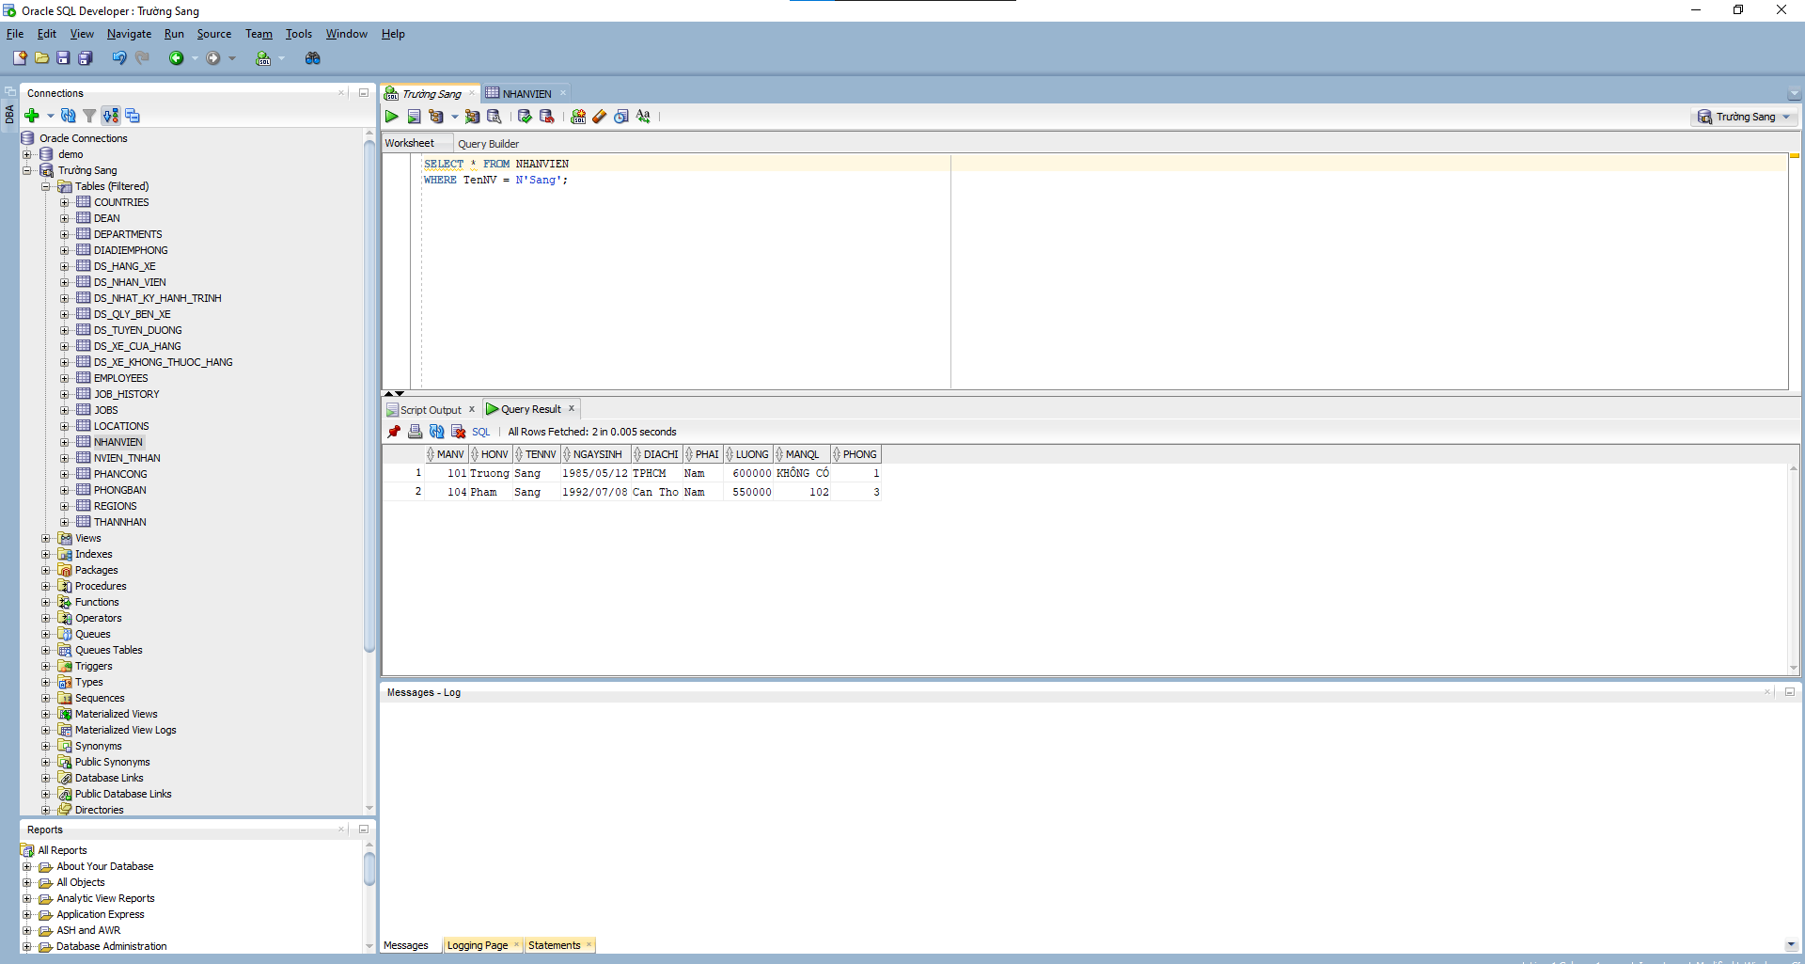
2 .SELECT MaNV, HoNV, TenNV, DiaChi
FROM NHANVIEN JOIN PHONGBAN ON Phong = MaPhong
WHERE TenPhong = N'Hành Chính';
3 .SELECT MaNV, HoNV, TenNV, DiaChi
FROM NHANVIEN JOIN PHONGBAN ON Phong = MaPhong
WHERE TenPhong IN (N'Hành Chính', N'Tài Vụ');
4 . SELECT nv.MaNV, nv.HoNV, nv.TenNV, da.TenDA
FROM NHANVIEN nv
JOIN PHANCONG pc ON nv.MaNV = pc.MaNV
JOIN DEAN da ON pc.MaDA = da.MaDA;
5 . SELECT da.MaDA, da.TenDA, pb.TenPhong, nv.MaNV AS MaTruongPhong, nv.TenNV AS TenTruongPhong
FROM DEAN da
JOIN PHONGBAN pb ON da.Phong = pb.MaPhong
JOIN NHANVIEN nv ON pb.TruongPhong = nv.MaNV;
6 . SELECT nv.MaNV, nv.HoNV, nv.TenNV
FROM NHANVIEN nv
JOIN PHANCONG pc ON nv.MaNV = pc.MaNV 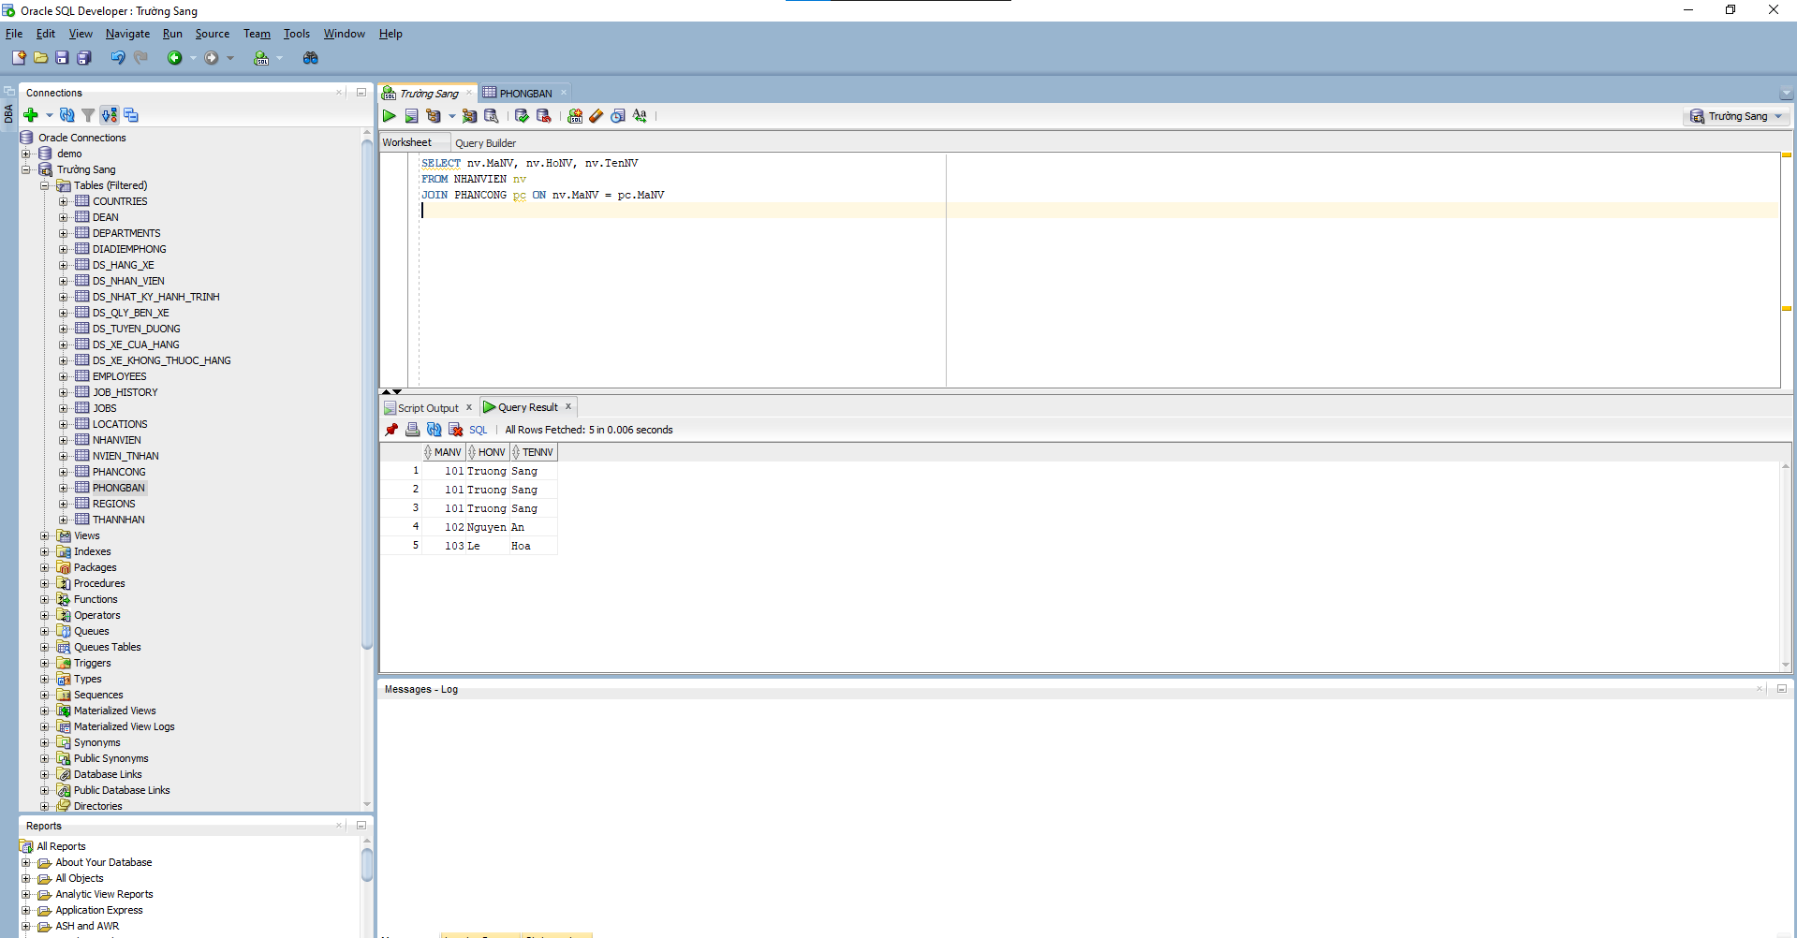
WHERE pc.MaDA = 'DA01' AND pc.ThoiGian > 30;
7 . SELECT DISTINCT nv.MaNV, nv.HoNV, nv.TenNV
FROM NHANVIEN nv
JOIN NVIEN_TNHAN nvtn ON nv.MaNV = nvtn.MaNV
JOIN THANNHAN tn ON nvtn.MaTN = tn.MaTN
WHERE nv.TenNV = tn.TenTN; 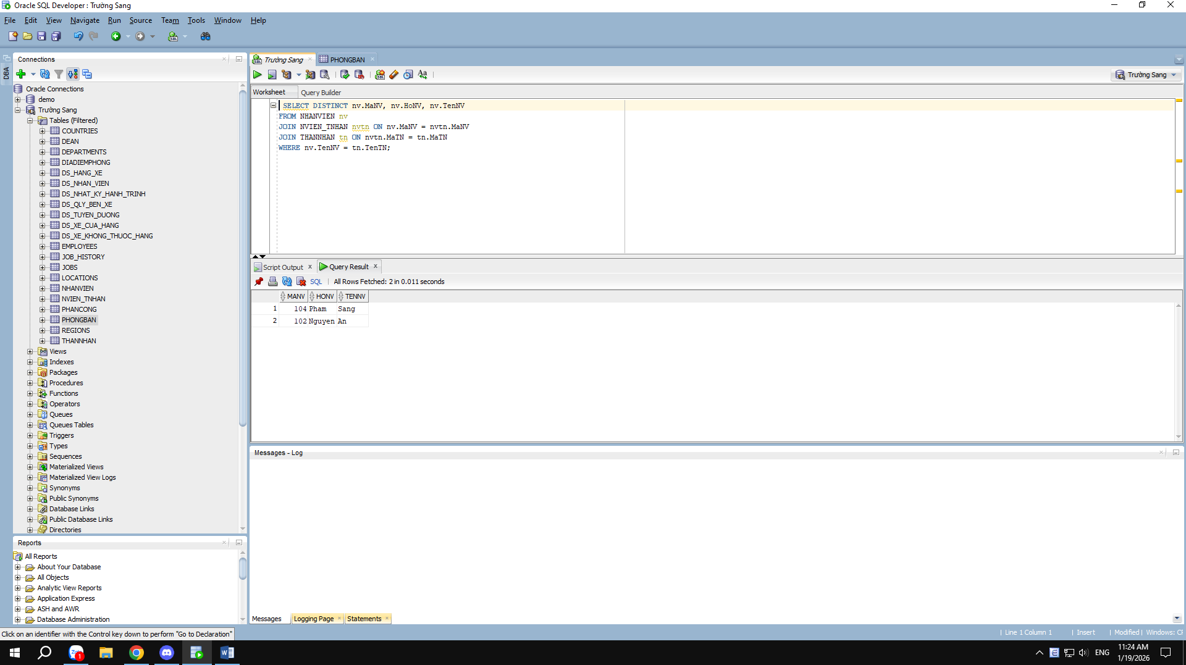
8 . SELECT nv.MaNV, nv.HoNV, nv.TenNV
FROM NHANVIEN nv
JOIN PHONGBAN pb ON nv.Phong = pb.MaPhong
JOIN NHANVIEN tp ON pb.TruongPhong = tp.MaNV
WHERE tp.HoNV = N'Trường' AND tp.TenNV = N'Sang';
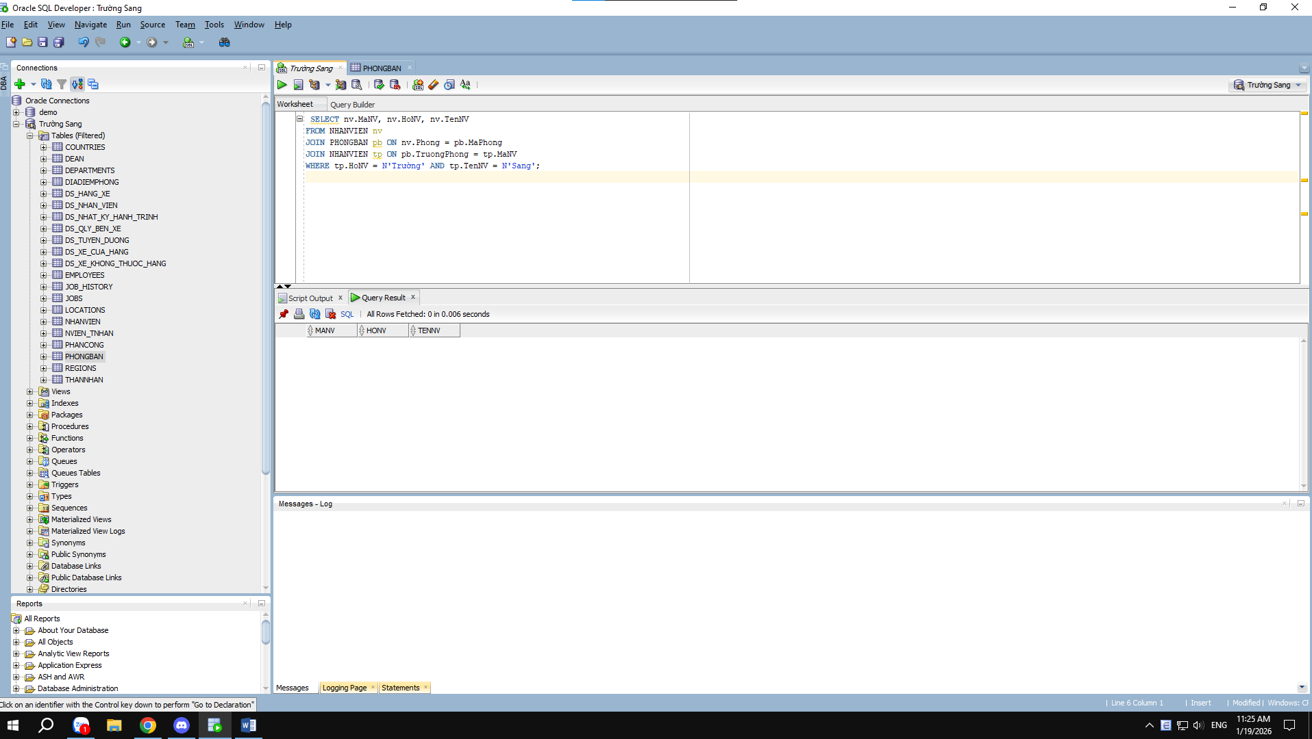
9 . SELECT nv.MaNV, nv.HoNV, nv.TenNV
FROM NHANVIEN nv
JOIN NHANVIEN ql ON nv.MaNQL = ql.MaNV
WHERE ql.HoNV LIKE '%Truong%' AND ql.TenNV LIKE '%Sang%'; 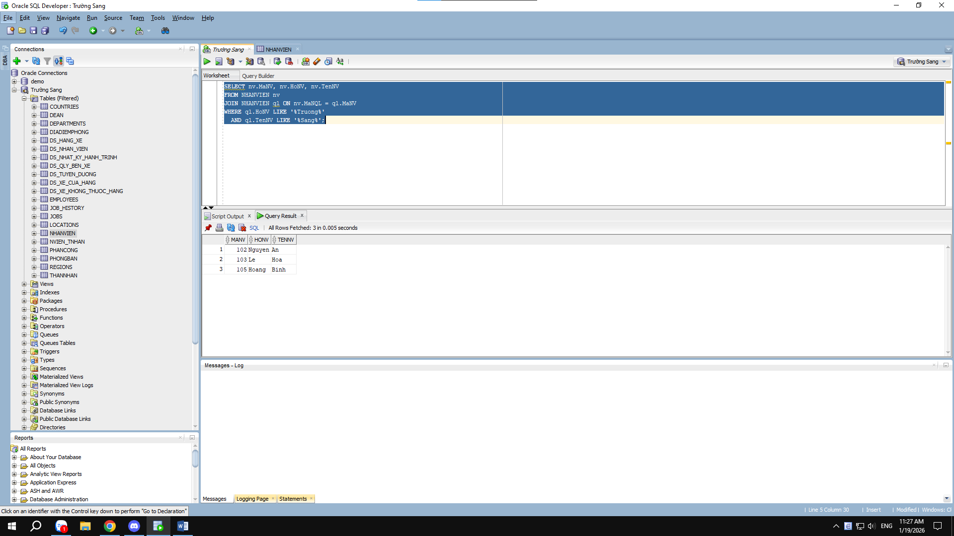
10 . SELECT MaNV, HoNV, TenNV
FROM NHANVIEN
WHERE MaNV IN (
SELECT MaNV FROM PHANCONG
GROUP BY MaNV
HAVING COUNT(MaDA) = (SELECT COUNT(*) FROM DEAN)
);
11 . SELECT MaNV, HoNV, TenNV
FROM NHANVIEN
WHERE MaNV NOT IN (SELECT MaNV FROM PHANCONG);
12 . SELECT AVG(Luong) AS LuongTrungBinh FROM NHANVIEN;
13 . SELECT AVG(Luong) AS LuongTrungBinhNam FROM NHANVIEN
WHERE Phai = N'Nam';
14 . SELECT COUNT(*) AS TongSoDeAn FROM DEAN;
15 . SELECT MaDA, COUNT(MaNV) AS SoLuongNV
FROM PHANCONG
GROUP BY MaDA;
16 . SELECT pc.MaDA, COUNT(nv.MaNV) AS SoLuongNVNu
FROM PHANCONG pc
JOIN NHANVIEN nv ON pc.MaNV = nv.MaNV
WHERE nv.Phai = N'Nữ'
GROUP BY pc.MaDA;
17 . UPDATE PHANCONG
SET ThoiGian = ThoiGian + 4
WHERE MaNV IN (SELECT MaNV FROM NHANVIEN WHERE Phai = N'Nam');
18 . DELETE FROM NHANVIEN WHERE Luong < 500000;

